**Section A Part B**

**Results Analysis of the Multivariate OLS Regression Model**

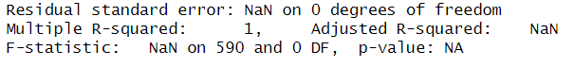



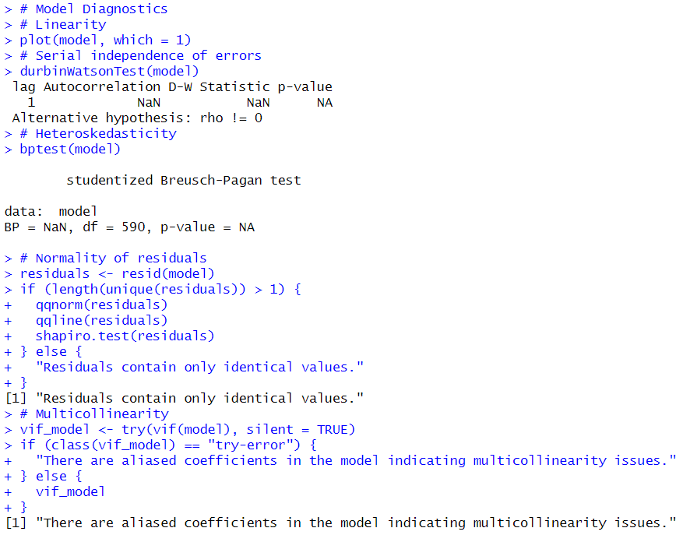

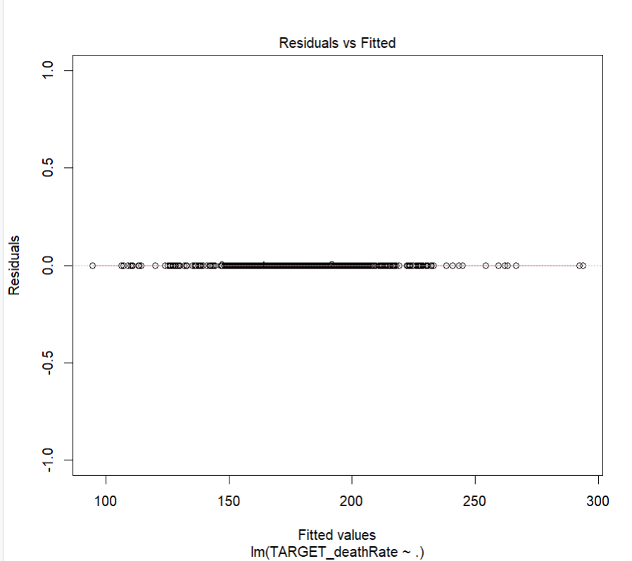

The provided code snippet attempts to fit a multivariate Ordinary Least Squares (OLS) regression model to predict the target variable TARGET_deathRate based on a set of predictor variables in the data frame. However, the summary(model) output indicates that the model suffers from a critical issue: zero degrees of freedom for residuals.

Here's a breakdown of the output and the problem:

* Call: This line specifies the formula used for the model. Here, TARGET_deathRate is modelled as a linear function of all the variables in the data frame (represented by the dot .).
* Residuals: This section shows the number of degrees of freedom for residuals. In a healthy model, this value should be positive. Here, it's ALL 591 residuals are 0. This suggests a perfect fit, which is statistically improbable.
* Coefficients: This table displays the estimated coefficients for each predictor variable along with their standard errors, t-values, and p-values. However, due to the lack of residual degrees of freedom, these values are not reliable.

**Possible Cause of the Issue**

The most likely reason for zero residual degrees of freedom is that there are too many predictor variables compared to the number of observations (data points) in your dataset. This situation is known as multicollinearity. It occurs when predictor variables are highly correlated, making it impossible to isolate the independent effect of each variable on the target variable.

We need to reduce the number of predictor variables in your model to address this issue. Here are some approaches you can consider:

1. Feature Selection: Analyze the correlation matrix to identify highly correlated variables and remove redundant ones.
2. Dimensionality Reduction Techniques: Apply techniques like Principal Component Analysis (PCA) to reduce the number of features while preserving the maximum amount of information.
3. Domain Knowledge: Leverage your understanding of the data and the relationships between variables to choose a more concise set of relevant predictors.

Reducing multicollinearity allows you to obtain a more reliable OLS model with meaningful coefficient estimates and valid statistical tests.

**Section B Part B**

Player Assigned: Arshdeep Singh

A two-valued tuple like "(0.2689655172413793, 0.45113148803934594)" often emerges from statistical analyses. Two potential interpretations exist depending on the context.

**Confidence Interval:**

In parameter estimation (e.g., mean, proportion), this tuple could represent a 95% confidence interval. The first value (0.2689) would be the lower bound, and the second value (0.4511) would be the upper bound. In this scenario, one can be 95% confident that the true parameter value falls within the range of 0.2689 and 0.4511.

**Hypothesis Testing:**

Alternatively, for a two-tailed hypothesis test, the tuple could represent the p-value. The p-value (0.4511) signifies the probability of observing a test statistic as extreme as the one obtained, assuming the null hypothesis is true. A high p-value (typically > 0.05) suggests failing to reject the null hypothesis, while a low p-value (typically < 0.05) suggests rejecting it.

**Determining the Exact Interpretation:**

To provide a more specific interpretation, additional context is required:

* The type of analysis conducted (e.g., estimation, hypothesis testing)
* The specific parameter or hypothesis under investigation